Submit a brief report comparing the error properties of each integrator with the exact option price. Your studies should compare the convergence properties of each scheme as M and N vary.

Problem 1:

Parameters: S0 = 100.0, K = 110.0, T = 2.5, Sigma = 0.4

Calculated r = 0.14500000000000002

Checkpoints: [ 100 1000 10000 100000 1000000 10000000]

Expected results:

# matlab: [Call, Put] = blsprice(100,110,0.145,2.5,0.4)

# Call = 35.4805

# bsformula results for Call option:

# Price = 35.4805

Calculated results:

TV: 35.49653984428261

Means:

[34.39654686320733, 33.732872405872264, 35.28498242177358, 36.0344525995199, 35.59248294108394, 35.49653984428261]

StdDevs:

[49.52242479655789, 57.0501619951988, 60.69357472205613, 62.25308071358687, 61.671569721735935, 61.54007341980069]

StdErrs:

[4.977190962387117, 1.8049872472239428, 0.606966096284121, 0.19686251073224917, 0.06167160055754393, 0.019460680911089826]

Problem 2:

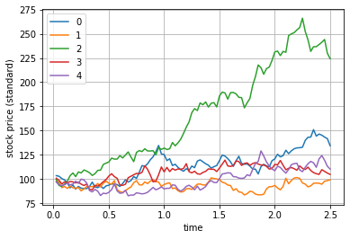

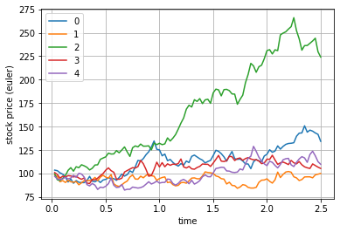

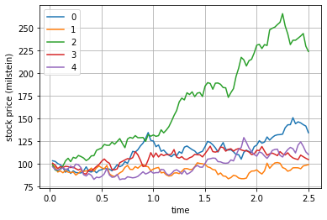

Problem 3:

Checkpoints:

[ 100 1000 10000 100000 1000000]

Parameters:

S0 = 100.0, K = 110.0, T = 2.5, Sigma = 0.4

Expected results:

# matlab: [Call, Put] = blsprice(100,110,0.145,2.5,0.4)

# Call = 35.4805

# bsformula results for Call option:

# Price = 35.4805

Calculated results (standard):

TV:

35.48338318791778

Means:

[29.722296066897727, 34.541839526323166, 34.24417972469878, 35.262388984074306, 35.48338318791778]

StdDevs:

[61.18473509154717, 61.082557227952904, 60.28572792856267, 60.935086987624516, 61.61404940936626]

StdErrs:

[6.149297248362221, 1.9325665864640367, 0.6028874244104941, 0.19269462777692944, 0.06161408021641407]

Calculated results (euler):

TV:

35.43096338909623

Means:

[29.33355513353872, 34.517208004605706, 34.21545311338942, 35.23129512799912, 35.43096338909623]

StdDevs:

[59.401543244412565, 60.61129354950881, 59.895770630750604, 60.4926520944778, 61.10986662854206]

StdErrs:

[5.9700797245390005, 1.9176564635139381, 0.5989876564391, 0.19129551880269027, 0.06110989718349829]

Calculated results (milstein):

TV:

35.36321676153551

Means:

[29.62457313415739, 34.42476275495708, 34.13095935573114, 35.143955422717376, 35.36321676153551]

StdDevs:

[60.87846454315367, 60.74818954369393, 59.95535670361727, 60.60697346205395, 61.279824676868714]

StdErrs:

[6.118515900078657, 1.9219876610961817, 0.5995835469630377, 0.1916570365170493, 0.06127985531680403]

